# Red Team: Summary of Operations

## 

## Table of Contents

* Exposed Services
* Critical Vulnerabilities
* Exploitation

### Exposed Services

TODO: Fill out the information below.

Nmap scan results for each machine reveal the below services and OS details:

$ nmap -sn 192.168.1.0/24

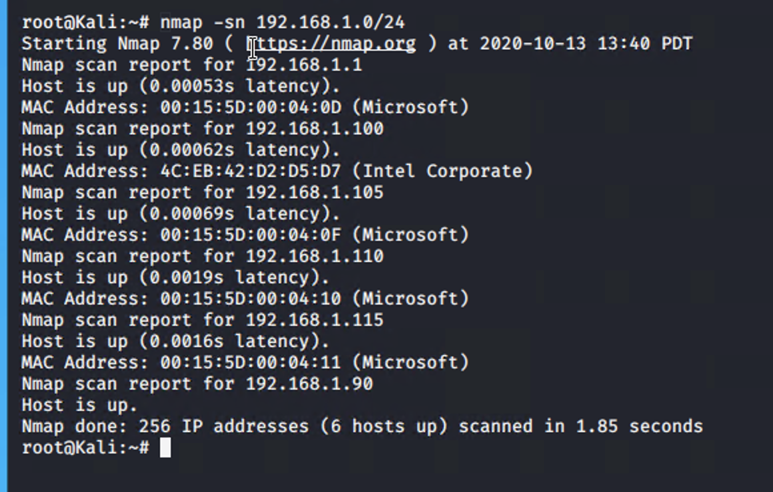

$ nmap -A 192.168.1.110

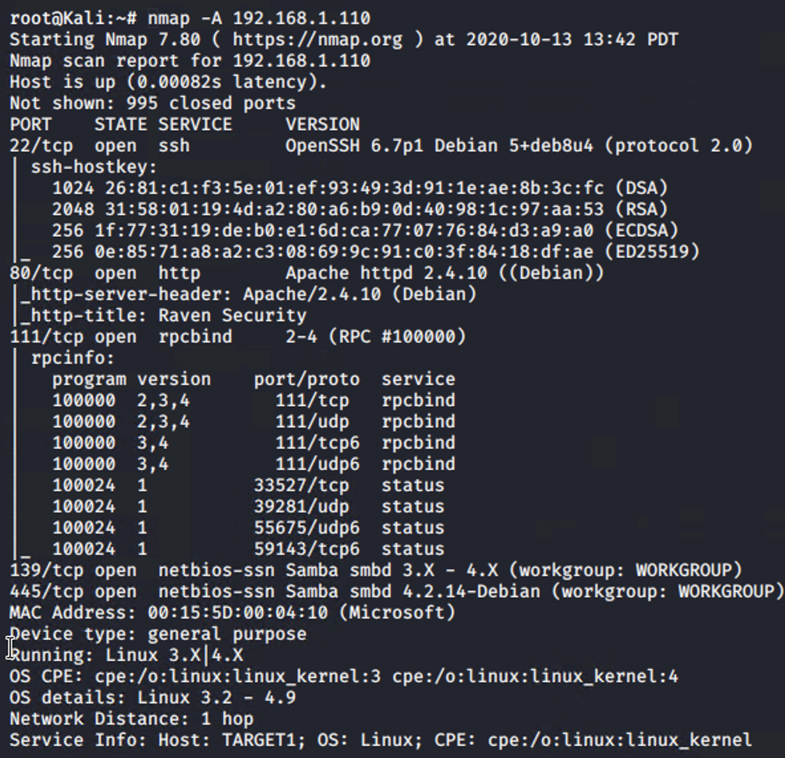

This scan identifies the services below as potential points of entry:

**Target 1**

1. 22/tcp open openSSH 6.7p1 Debian 5+deb8u4 (protocol 2.0)
2. 80/tcp open http Apache httpd 2.4.10 ((Debian))
3. 111/tcp open rpcbind 2-4 (RPC #10000)

**Target 2**

1. List of exposed services
2. List of exposed services
3. List of exposed services

### Critical Vulnerabilities

TODO: Fill out the list below. Include severity and CVE numbers, if possible.

The following vulnerabilities were identified on each target:

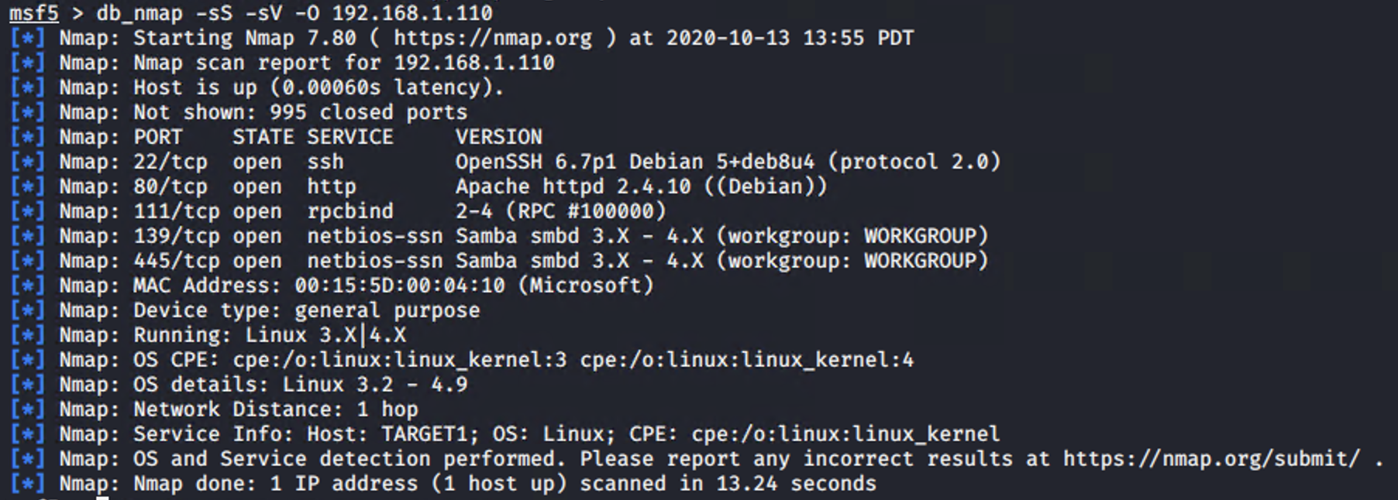

**Target 1**

1. 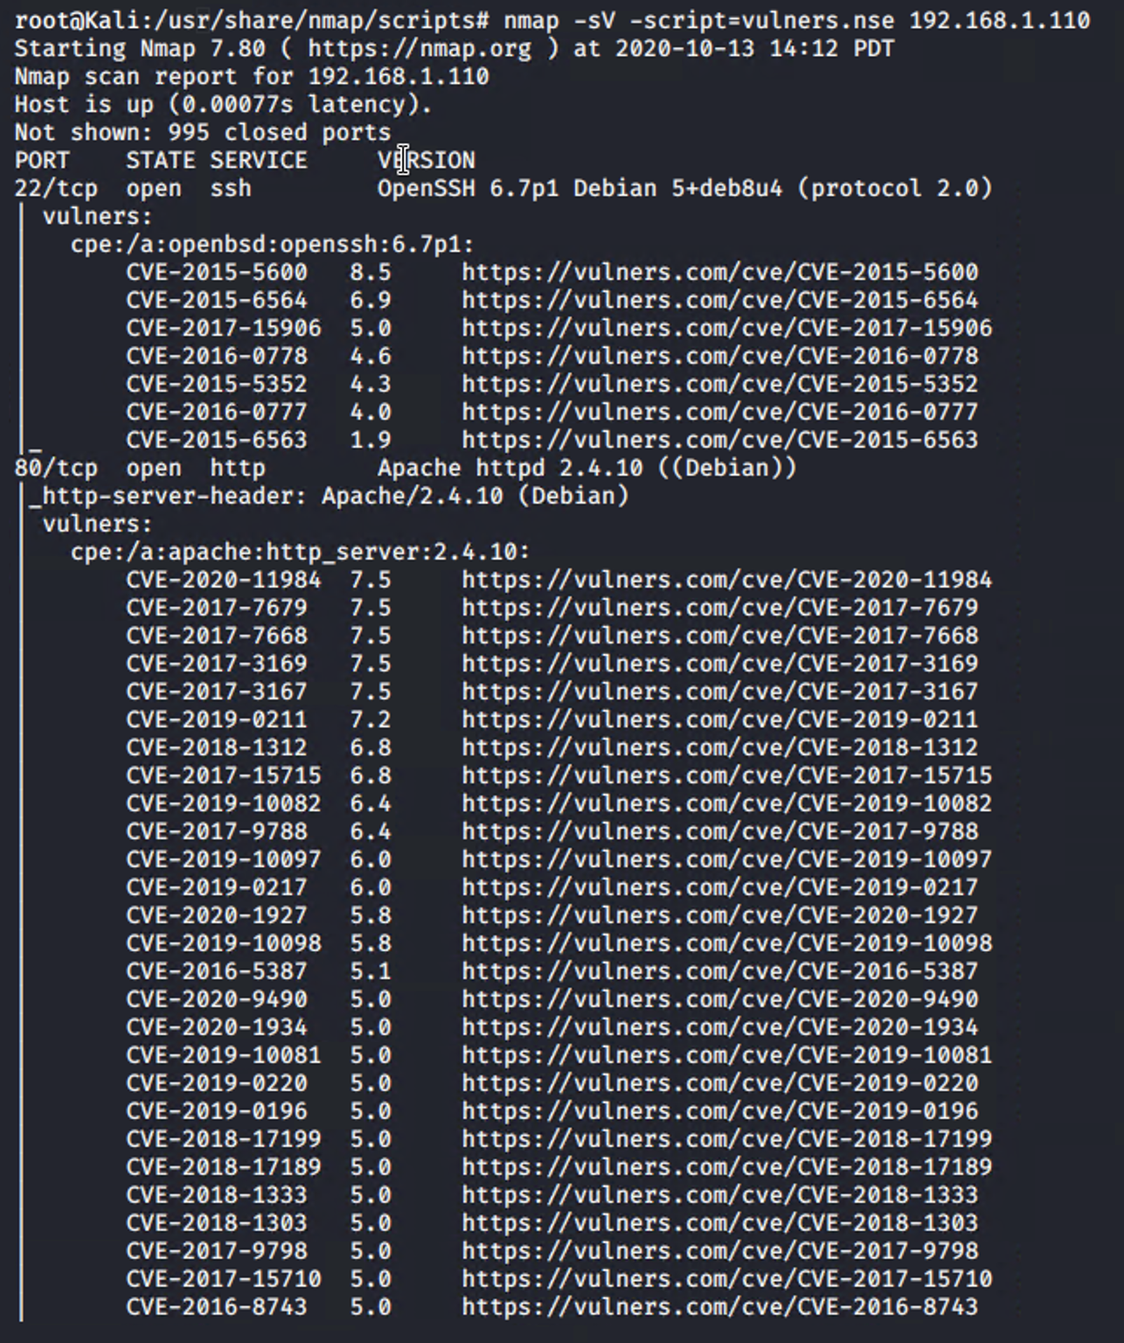

**Target 2**

1. List of critical vulnerabilities
2. List of critical vulnerabilities
3. List of critical vulnerabilities

TODO: Include vulnerability scan results as proof of the identified vulnerabilities.

Exploitation

TODO: Fill out the details below. Include screenshots where possible.

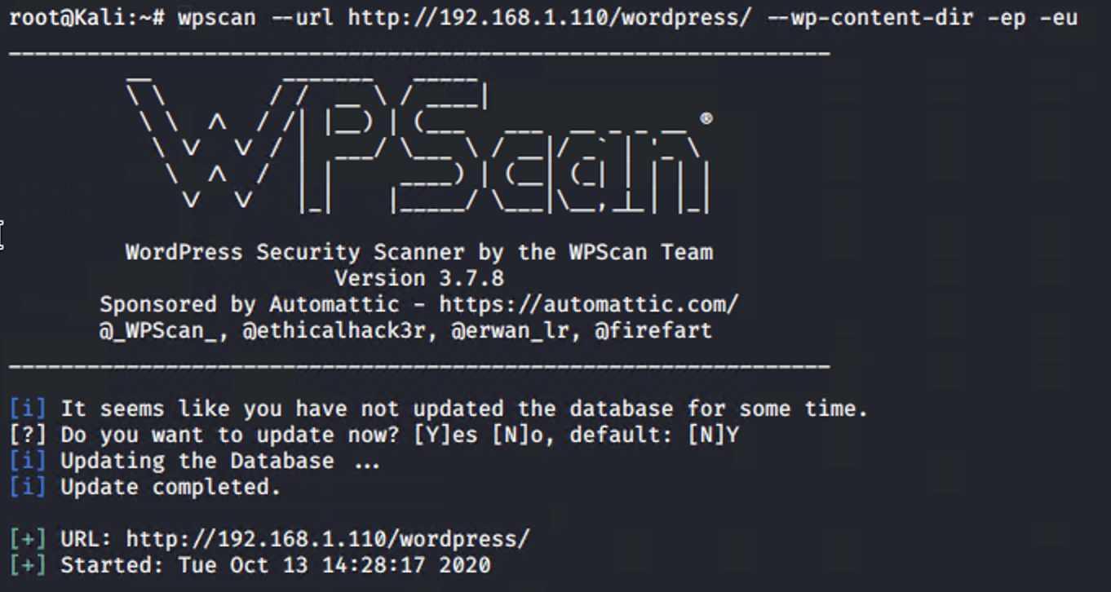

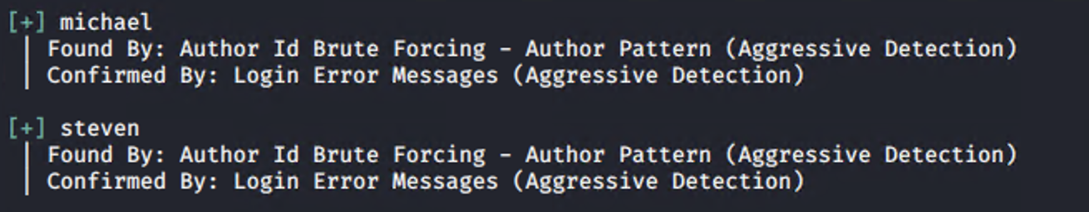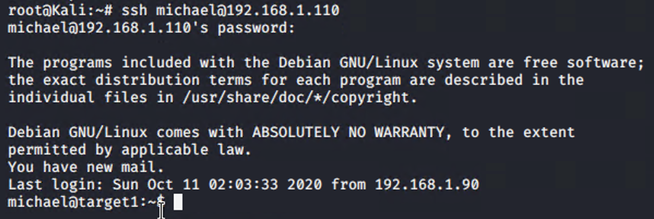



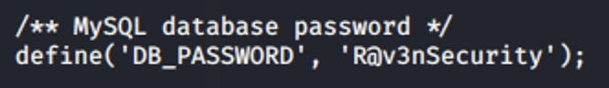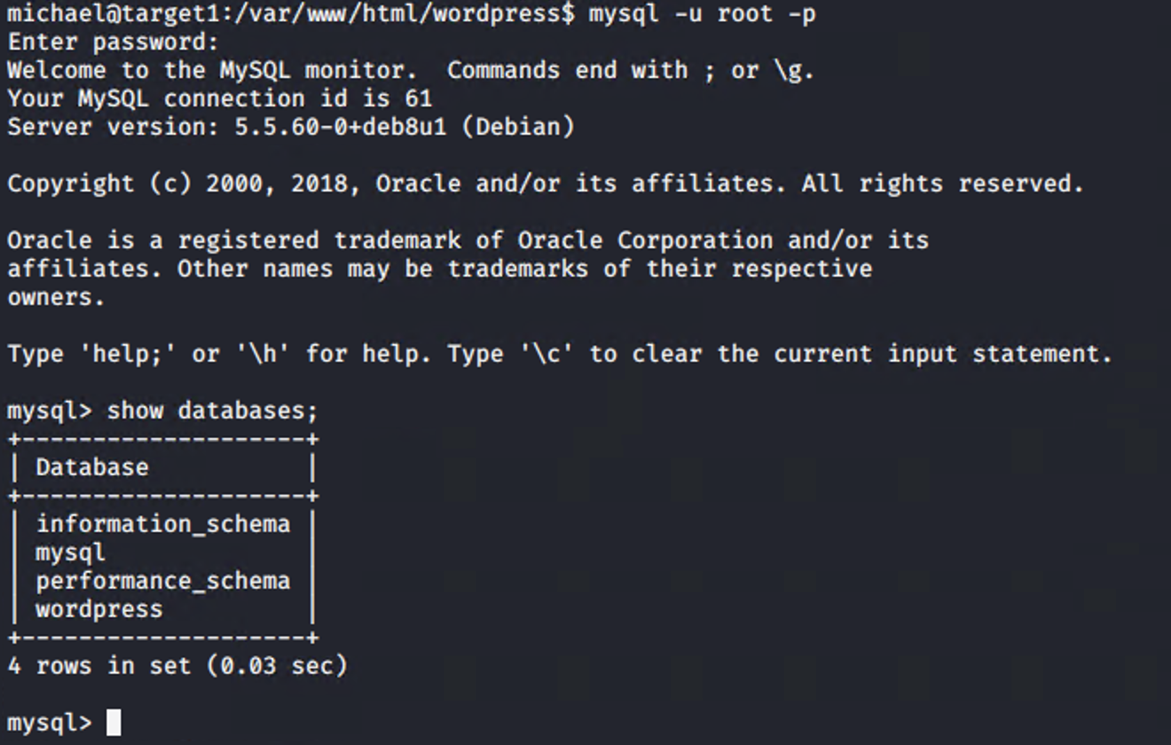

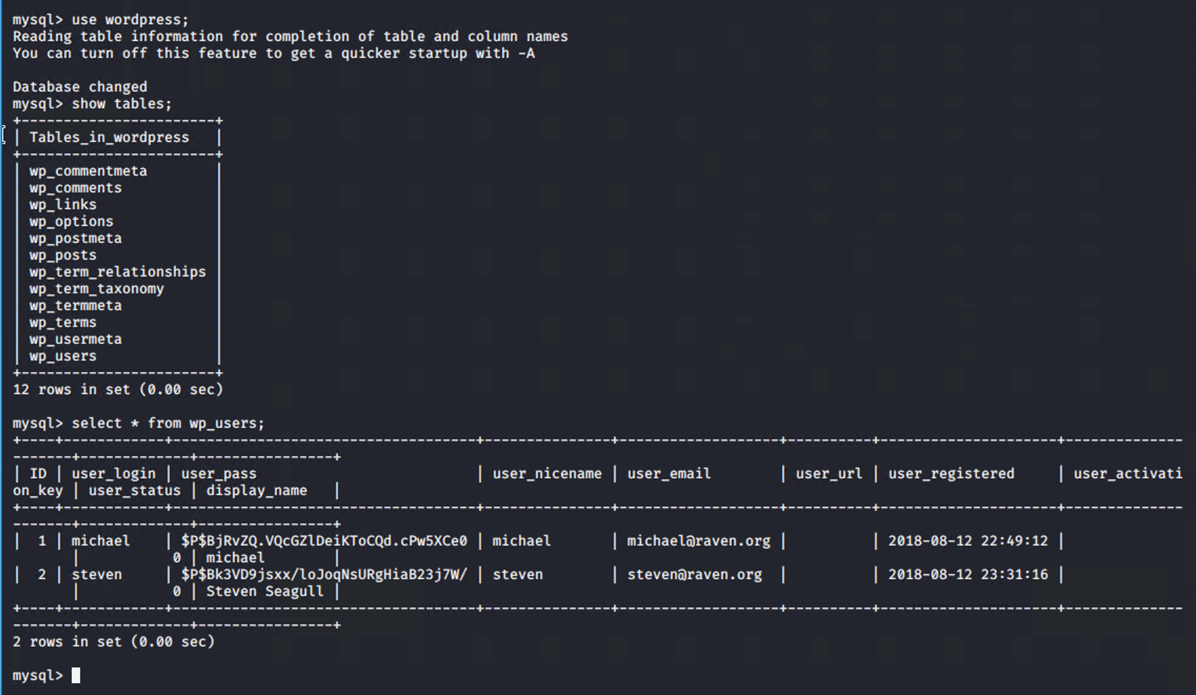

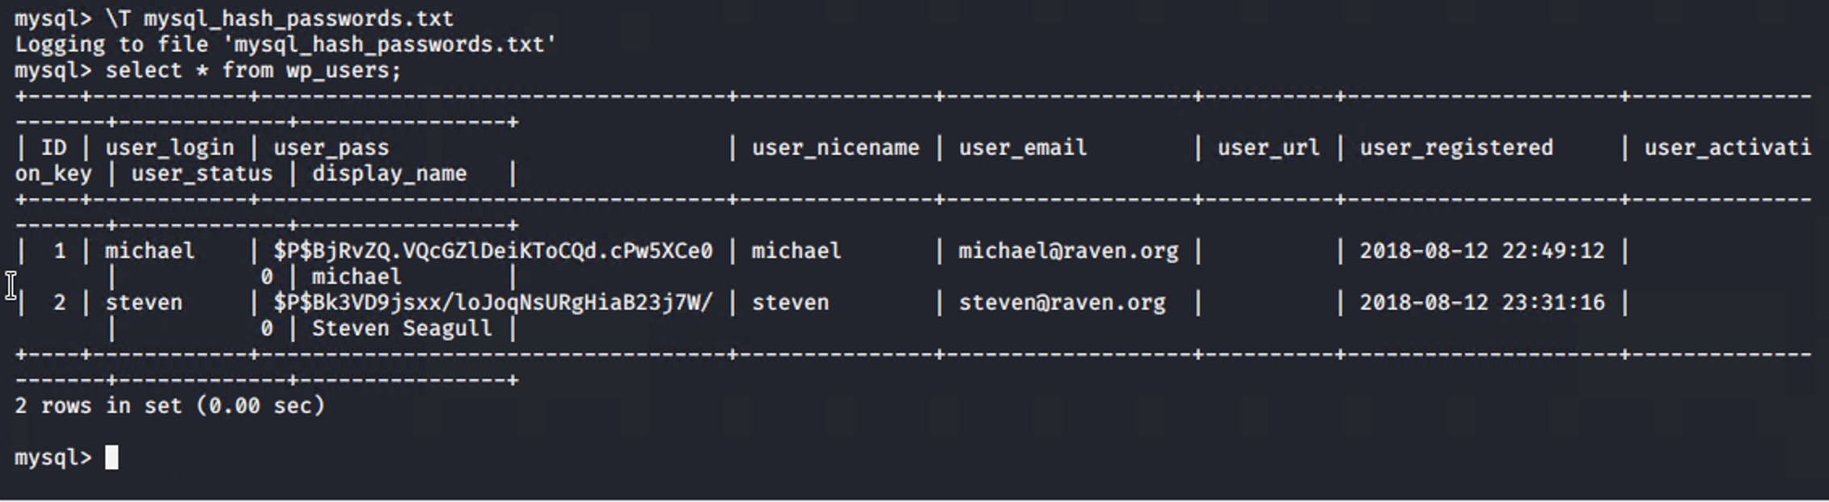



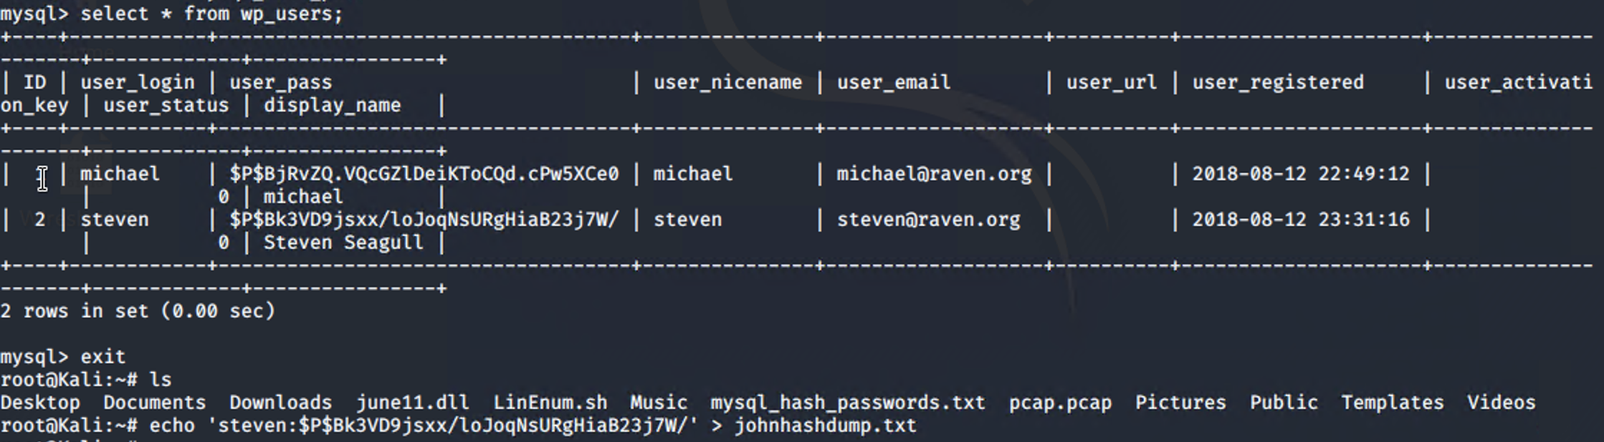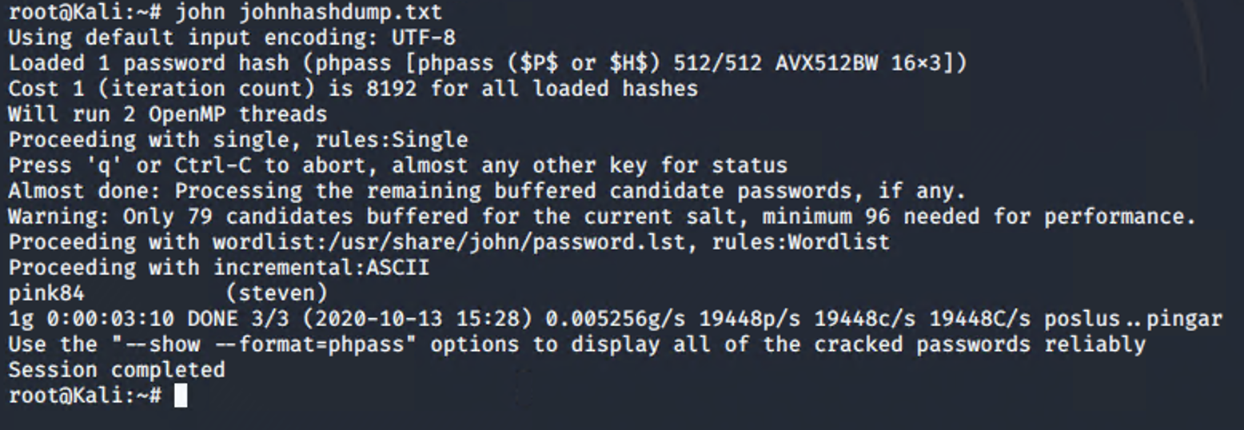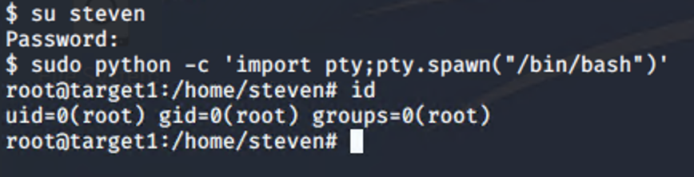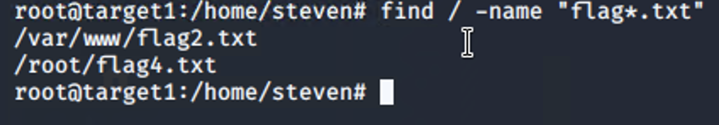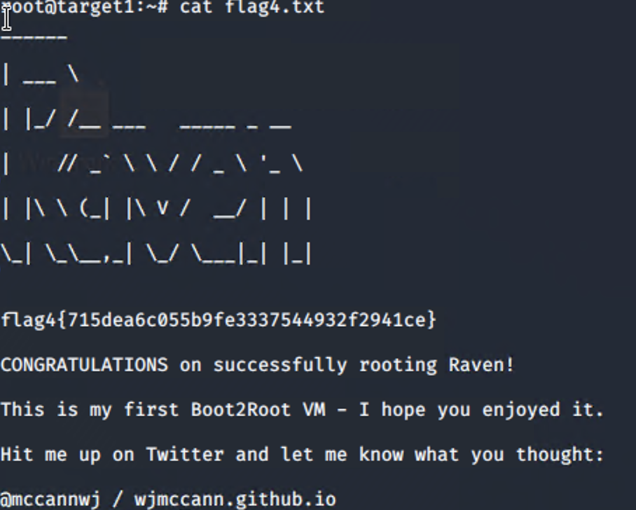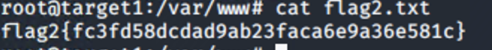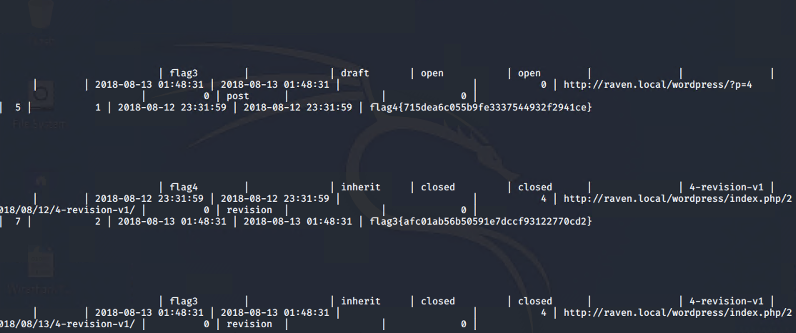The Red Team was able to penetrate both Target 1 and Target 2 and retrieve the following confidential data:

**Target 1**

*See screenshots for exploits used and commands*

* flag1.txt: TODO: Insert flag1.txt hash value.
* Exploit Used
  + TODO: Identify the exploit used.
  + TODO: Include the command run.
* flag2.txt: TODO: Insert flag2.txt hash value.
* Exploit Used
  + TODO: Identify the exploit used.
  + TODO: Include the command run.